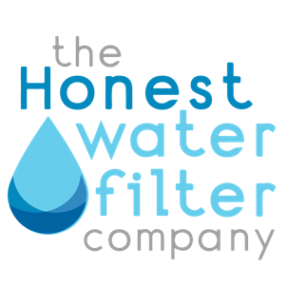
FOR IMMEDIATE RELEASE

REVOLUTIONARY WATER TREATMENT SYSTEM RECEIVES COVETED NSF STANDARD 53 CERTIFICATION

Temecula, CA – June 11, 2024 – In a significant announcement for the water treatment industry, The Honest Water Filter Company proudly announces that its cutting-edge Diamond Ultra-Filter system has been awarded the prestigious NSF Standard 53 certification for health effects.

Diamond Ultra-Filter System Meets Rigorous Standard 53 Certification

NSF International Standard 53 is internationally recognized as the benchmark for water filtration systems’ effectiveness in reducing specific health-related contaminants. Achieving this certification signifies that The Honest Water Filter Company’s Diamond Ultra-Filter system meets the stringent standards set forth by NSF International, ensuring consumers that the product effectively removes a wide range of harmful substances from drinking water.

Through a combination of innovative filtration media and rigorous testing protocols, the Diamond Ultra-Filter delivers clean, safer water directly from every tap in the home.

“We are thrilled to receive the NSF Standard 53 certification, which underscores our unwavering commitment to providing the highest quality water treatment solutions to our customers,” said Eric Brockmire, President and Founder of The Honest Water Filter Company. “This achievement is a reflection of years of collaboration and testing in developing innovative products that prioritize consumer health and well-being,” Eric continued.

With the growing concerns about water quality and its impact on public health, consumers are increasingly seeking reliable solutions to ensure the purity and safety of their drinking water. By obtaining the NSF Standard 53 certification, The Honest Water Filter Company reinforces its position as a trusted leader in water treatment, offering products that meet the highest standards of performance, reliability, and safety.

For more information about The Honest Water Filter Company and its NSF Standard 53 certified Diamond Ultra-Filter system, please visit https://honestwaterfilter.com.

About The Honest Water Filter Company:
The Honest Water Filter Company is a leading provider of innovative water treatment solutions designed to enhance the quality, safety, and taste of drinking water. With a focus on advanced filtration technologies and rigorous quality standards, The Honest Water Filter Company is dedicated to delivering superior products that meet the growing needs of concerned residential customers for better water.

Contact:
John Phipps
Vice President of Marketing
The Honest Water Filter Company
760-208-7470
john@honestwaterfilter.com
https://honestwaterfilter.com

